**Presentation Notes**

1. Summarize the main features of a Code Repository
   1. Used for sharing
   2. Files have version control
   3. Files are submitted using "commit update"
   4. File changes are therefore easily tracked and managed
   5. Interface is designed for efficiency
   6. maintaining computer program code and collaborating on code development.

1. List some differences between a Code Repository and other file sharing services

- GitHub does not have the on-line editing tools provided by other services - Does not have many of the business / education related collaboration tools  
- Files are easily tracked and managed easily rather than other services

1. List some of the reasons why we are using GitHub in this course
   1. Many game map editors, game mods, and patches are on GitHub
   2. Most popular service in the software development community
   3. Free to use

1. You will be using 2 different GitHub repositories in this course. Explain what they are:
   1. Mr. Nestor’s repository
   2. My repository
2. Label the following parts of the GitHub interface using the diagram below.
   1. File content link
   2. Timestamp information
   3. Button to upload files
   4. Repository link & path information

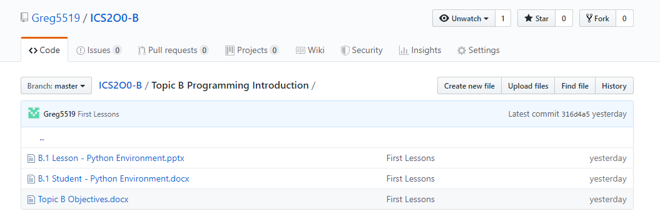

1. List some privacy concerns related to using GitHub.

* Your account profile is visible to anyone on the web
* Content you upload to your repository is visible to anyone on the web

1. Summarize the guidelines you should follow when creating a user account for school work on 3rd party software.

You should not use you pdsb.net student email for any contact information, or user ID. You should use a fake user ID and should not use any personal information

1. List some of the main features of a Terms of Service (TOS) agreement.
   1. Defines proper and expected use of the service
   2. Defines what is misuse of the service
   3. Outlines membership, subscription and payment details
   4. Outlines the procedure for closing an account
   5. Clarifies the legal liability and dispute resolution process
2. List some of the main features of a Privacy Policy.
   1. Discloses what personal information about you is collected and stored
   2. Outlines how and when your personal information is collected
   3. Defines who your personal information is shared with
3. Summarize the difference between a TOS and a Privacy Policy.

A TOS protects the company from you, it is not required by law but put in place for the benefit of the company. A Privacy Policy protects you from the company, it is required by law not because the company wants it.

**Module Questions**

1. Review the Terms of Service (TOS) agreement for the GitHub service.
   1. Open the link: (<https://help.github.com/articles/github-terms-of-service/>)
   2. Summarize the section that confirms that you are permitted to use this software for this class.
   3. Explain what rights do you give up by using this software.

By agreeing to these Terms, you are giving us permission to charge your on-file credit card, PayPal account, or other approved methods of payment for fees that you authorize for GitHub.

* 1. Explain what limitations you have when using this software.

While using the service, you must follow the terms of this section, which include some restrictions on content you can post, conduct on the service, and other limitations. In short, be excellent to each other.

1. Review the Privacy Policy for the GitHub service.
   1. Open the link: (<https://help.github.com/articles/github-privacy-statement/>)
   2. What information does GitHub collect and track?
   3. Summarize how GitHub shares your information.
   4. How does GitHub communicate with you?

GitHub will be used to share course files in a similar way to MyClass or D2L. The reason we are using GitHub is because this is the tool preferred by many software developers and is the most common way to share computer code on the internet.

The Peel School Board is concerned about the privacy and safety of its students and has issued the following guidelines for using third party applications:

* Do not provide: First & Last Name
* Do not provide: Birthday
* Do not provide: Personal Address & Contact Information
* Do not provide: Student Number
* Your @pdsb.net email address can be used but cannot be used as a login id.

1. Based on your understanding of the GitHub privacy policy, list two benefits and two drawbacks of following the Peel Board guidelines listed above.
2. Create an account on GitHub.com following the Peel Board guidelines listed above.
   1. **NOTE:** Make sure to select the free student plan when creating your account.

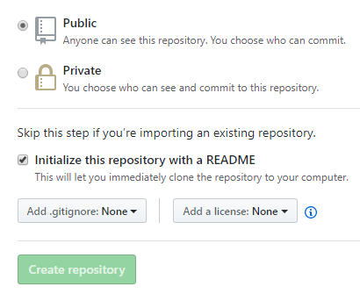

1. Create a new Repository for your ICS2O0 course work.
   1. Give your repository a meaningful name like “ICS2O0_Work”
   2. **Note:** Make sure to select "Public Repository"
   3. **Note:** Make sure to select “Include a ReadMe file”
2. Email Mr. Nestor (p0079141@pdsb.net) the following information:
3. Your Name
4. The link to your repository

Your personal GitHub repository will be used to store and manage your work for this course. You should save partially completed work in your repository and you can update it at any time from school or at home. GitHub automatically keeps track of updates to your files. You should NEVER make multiple VERSION COPIES of your work files.

Your repository should be shared with your teacher and with other members of your work group.

1. Open Mr. Nestor's repository for this class.
   1. You should have bookmarked the link in an earlier part of this lesson.
   2. This repository is the source for all course information and lesson files (much like D2L or Google Classroom is used by other teachers).
   3. Note the structure and organization of Mr. Nestor’s repository. In particular, note the folders such as “Topic A”, "Topic B", etc.
2. Duplicate the organization structure and folder names in your personal repository.
   1. Your personal GitHub repository will be used to upload and manage your work completed for this course.
   2. Your repository needs to be well organized so that Mr. Nestor can easily find your work and give you credit for it.
   3. **NOTE:** There is a “trick” required to create folders in GitHub.
   4. See if you can find this trick and share it with your neighbours.
   5. Check-in with Mr. Nestor to make sure you have found the trick.
3. Upload your answers to this module (i.e. the “A.1 Student - GitHub Repositories” )
   1. Make sure to store it in the proper folder.
   2. Use the "Upload" button in the GitHub screen and drag and drop you file.
   3. Make sure to "Commit" your changes at the bottom of the upload screen.
   4. You can upload and commit partially completed work now and then upload the same file again at a later time; GitHub automatically keeps track of your changes.

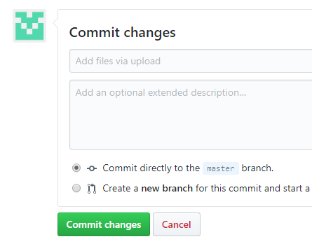

1. Email Mr. Nestor ([p0079141@pdsb.net](mailto:p0079141@pdsb.net)) when you have completed this work.

Work will be submitted (handed in) by uploading it to your repository . ONLY work uploaded to your repository will be considered handed in and will be marked.